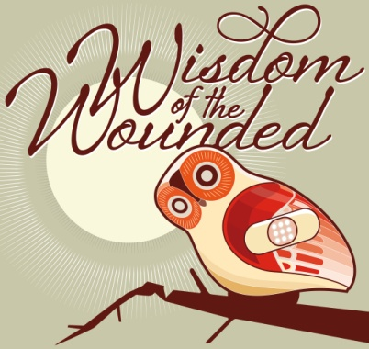
WISDOM FOR THE CAREGIVER
___________________
Substance Abuse

Wisdom for the Caregiver
- “I felt that the eyes of the whole town were on our son and our family. It was very difficult to go through the days and months when I felt as though everyone was talking about us. (Not everyone was, of course, but it felt that way!) One day at a younger child’s soccer game, another parent asked, ‘How’s Brian? I haven’t seen him in a while.’ I briefly but honestly told her. She had had no idea of our family’s crisis but she said, ‘Isn’t it difficult when our children make decisions that we know are wrong for them?’ That simple comment helped me so much. To me it said, ‘I know you must be hurting and I’m sorry,’ and also, ‘No child is perfect, all parents struggle.’ It was a simple comment on her part, but I needed to hear that I wasn’t being judged.” -Alice
- When my son went to treatment, we had a parent group (I was so grateful to see other ‘normal’ looking parents with the same problem!) We were told that as parents we had probably punished, talked, begged, screamed, threatened our children over their drug use, but it was to no avail. We were told that it was the child’s problem and that he had to deal with it. It was a hard thing to hear, because I wanted to be able to control this problem and solve it, but it was the truth. Our son could only change his life when he took responsibility for himself.” -Catherine

Teenage substance abuse has reached epidemic proportions. Many parents regard drinking as a normal part of their teen’s behavior. Drinking and drug abuse are serious negative habits that should be addressed before they get out of hand. Here are some guidelines.

- Don’t wait. Whatever your child’s age, state your position clearly when kids ask about liquor. Say, “These are our family’s rules,” and explain what they are.
- Team Up. Make a pact with our parents not to serve alcohol in your homes. Do not have alcohol in your home, or keep it under lock and key.
- Alert your child’s friend’s parents whenever their kids are found drinking. Some communities have formalized such agreements by having parents sign a pledge.
- Set a good example. If you do not drink in front of your children, they will be less likely to drink. Do not allow them to drink at home when you are under the assumption that this will remove the mystique of drinking and therefore curb drinking away from home.
- Check up on teens’ whereabouts. Even if you trust your kids, ask about how they are spending their time and with whom.

*For additional wisdom: see pages 195-202 in The Compassionate Congregation available through Amazon.com or via our website at www.WisdomoftheWounded.com

